Q. No. | Item Stem and Options | Correct Answer
Q1 | What is the value of camber recommended by IRC for type of road surface “water bound macadam” at areas of heavy rainfall? | 3
Q1_1 | 1.0%
Q1_2 | 1.7%
Q1_3 | 3.0%
Q1_4 | 5.5%
Q2 | Calculate the lag distance (a part of safe stopping sight distance) for a design speed of 70 kmph for two way traffic on a single lane road. Take reaction time of driver as 2.5 seconds and coefficient of friction 0.35. | 2
Q2_1 | 48.61 m
Q2_2 | 97.22 m
Q2_3 | 58.92 m
Q2_4 | 117.84 m
Q3 | The percentage of voids is found to be 40% in an angularity test conducted on coarse aggregates sample. Calculate its angularity number? | 3
Q3_1 | 4
Q3_2 | 2
Q3_3 | 7
Q3_4 | 11
Q4 | Which of the following test is used to determine impurities present in bitumen, in the form of inert materials? | 2
Q4_1 | Loss on melting test.
Q4_2 | Solubility test.
Q4_3 | Ring and ball test.
Q4_4 | Float test.
Q5 | For the calculation of California Bearing Ratio value of soil, the standard load sustained by standard aggregates at a penetration level 5 mm is taken as_____ | 4
Q5_1 | 1340 kg
Q5_2 | 1450 kg
Q5_3 | 1850 kg
Q5_4 | 2055 kg
Q6 | As per IRC-37, pavement of Expressways and Urban roads may be designed for a life of______ | 1
Q6_1 | 7 years
Q6_2 | 20 years
Q6_3 | 30years
Q6_4 | 50 years
Q7 | Stress overlap due to dual wheel load is shown in figure, if the load dispersion is assumed to be at an angle 45⁰, the complete stress overlap happens at a depth of_____measured from surface of contact.  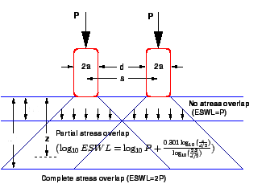 | 4
Q7_1 | d
Q7_2 | d/2
Q7_3 | s
Q7_4 | 2s
Q8 | Consider below statements with respect to grade compensation on curve for the movement of trains and identify correct answer  Statement A : On broad gauge tracks, 0.08% per degree of curve or 75/R, whichever is minimum should be provided  Statement B : On meter gauge tracks, 0.02% per degree of curve or 35/R, whichever is minimum should be provided | 4
Q8_1 | Statement A is correct and B is incorrect
Q8_2 | Statement B is correct and A is incorrect
Q8_3 | Both statements are correct
Q8_4 | Both statements are incorrect
Q9 | What will be the shape and size (mm) for STOP Sign if the speed is 120 kmph on an Expressway? | 1
Q9_1 | Octagonal and 1200 mm size
Q9_2 | Octagonal and 900 mm size
Q9_3 | Triangle and 1500 mm size
Q9_4 | Circle and 1000 mm size
Q10 | The sign shown in below figure is meant to inform the road users that _________ | 4
Q10_1 | Meandering road
Q10_2 | Uneven road
Q10_3 | Curved roads
Q10_4 | Slippery road
Q11 | As per IS 10500-2012, the acceptable limit of Chloramines content in drinking water is___________mg/l | 1
Q11_1 | 4
Q11_2 | 10
Q11_3 | 25
Q11_4 | 500
Q12 | According to Ministry of Environment, forest and climate change Government of India, Which of the following class of water can be used as Drinking water source after conventional treatment and disinfection? | 3
Q12_1 | Class A
Q12_2 | Class B
Q12_3 | Class C
Q12_4 | Class D
Q13 | Consider below statements with respect to turbidity of water and identify correct answer.  Statement A : Turbidity of water is not imparted by the dissolved matter present in water  Statement B : Jackson’s turbid meter is a laboratory apparatus which is used to measure turbidity of water | 3
Q13_1 | Statement A is correct and B is incorrect
Q13_2 | Statement B is correct and A is incorrect
Q13_3 | Both statements are correct
Q13_4 | Both statements are incorrect
Q14 | Consider below statements with respect to unit operations employed in water treatment and identify correct answer.  Statement A : Objectionable gases such as carbon dioxide and hydrogen sulfide present in water can be removed by bubble aeration technique.  Statement B : Chemical coagulation technique removes only the colloidal impurities present in water but not the suspended impurities. | 1
Q14_1 | Statement A is correct and B is incorrect
Q14_2 | Statement B is correct and A is incorrect
Q14_3 | Both statements are correct
Q14_4 | Both statements are incorrect
Q15 | Consider below statements and identify correct answer  Statement A: Humans dying of carbon monoxide inhalations exhibit characteristic bright pink colour of the flesh.  Statement B: Carbon monoxide is a permanent pollutant. | 1
Q15_1 | Statement A is correct and B is incorrect
Q15_2 | Statement B is correct and A is incorrect
Q15_3 | Both statements are correct
Q15_4 | Both statements are incorrect
Q16 | As per IS 1950: 1962, what is the maximum acceptable noise levels inside hospital, from the point of view of comfort, economy and practical considerations? | 2
Q16_1 | 55 to 60 dB
Q16_2 | 40 to 50 dB
Q16_3 | 5 to 15 dB
Q16_4 | 20 to 35 dB
Q17 | Consider below statements with respect to Sewer appurtenances used in sewerage system and identify correct answer.  Statement A : Lamphole may be located when there is change in the direction or gradient of the sewer in between two closely spaced manholes  Statement B : Flushing tanks shall be constructed when there is a steeper downward gradient along the alignment of sewer line. | 1
Q17_1 | Statement A is correct and B is incorrect
Q17_2 | Statement B is correct and A is incorrect
Q17_3 | Both statements are correct
Q17_4 | Both statements are incorrect
Q18 | Consider below statements with respect to biological treatment of waste water and identify correct answer  Statement A: Objective of the biological treatment of wastewater is to remove organic matter from the wastewater which is present in soluble and colloidal form.  Statement B: Biological treatment of wastewater does not remove nutrients such as nitrogen and phosphorous from the wastewater. | 1
Q18_1 | Statement A is correct but B is incorrect
Q18_2 | Statement B is correct but A is incorrect
Q18_3 | Both statements are correct
Q18_4 | Both statements are incorrect
Q19 | Which of the following is not a primary air pollutant? | 4
Q19_1 | Sulphur dioxide
Q19_2 | Carbon dioxide
Q19_3 | Suspended particulate matter
Q19_4 | Farmaldehydes
Q20 | Which of the following is not used as a landfill sealant for the control of landfill gas and leachate movement? | 2
Q20_1 | Compacted clay layer
Q20_2 | Compacted gravel layer
Q20_3 | Synthetic membrane liners
Q20_4 | Gunite concrete
Q21 | Calculate the bulk modulus of an alloy body, if its modulus of elasticity is found to be 250 Gpa. Consider that the poisson’s ratio of tested material as 0.3. | 2
Q21_1 | 156.89 GPa
Q21_2 | 208.33 GPa
Q21_3 | 122.32 GPa
Q21_4 | 238.98 GPa
Q22 | Calculate the moment of inertia of a circular lamina with radius 40 cm with respect to diametric axis. | 2
Q22_1 | 2.56 π x10⁴ cm⁴
Q22_2 | 6.4 π x10⁵ cm⁴
Q22_3 | 8.6 π x10⁵ cm⁴
Q22_4 | 12.56 π x10⁵ cm⁴
Q23 | Consider the below statements with respect to type of beams and identify incorrect statement | 4
Q23_1 | A fixed support beam is an indeterminate structure
Q23_2 | A simply supported beam is a determinate structure
Q23_3 | A continuous beam is an indeterminate structure
Q23_4 | A propped cantilever beam is a determinate structure
Q24 | Calculate the maximum deflection in a cantilever beam ‘BA’ subjected to a load with intensity varying from 0 N/m at ‘B’ to ‘W’ N/m at ‘A’ shown in figure? 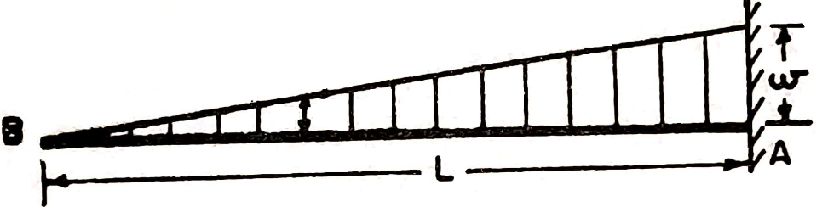Consider that EI is constant throughout the span, Where, E= young’s modulus of elasticity and I= second moment of area of beam cross-section | 2
Q24_1 | $$\frac{{wL}^{3}}{3EI}$$
Q24_2 | $$\frac{{wL}^{4}}{30EI}$$
Q24_3 | $$\frac{{wL}^{3}}{48EI}$$
Q24_4 | $$\frac{{5wL}^{4}}{30EI}$$
Q25 | Consider below statements with respect to characteristics of bending moment diagram (BMD) for beam and identify correct answer.  Statement A : If a beam is subjected to uniformly distributed load throughout its span, the shape of BMD will be cubic parabolic curve  Statement B : If a cantilever beam is subjected to a uniformly distributed load(UDL) throughout its span the maximum value of bending moment will be at its mid span. | 4
Q25_1 | Statement A is correct and B is incorrect
Q25_2 | Statement B is correct and A is incorrect
Q25_3 | Both statements are correct
Q25_4 | Both statements are incorrect
Q26 | 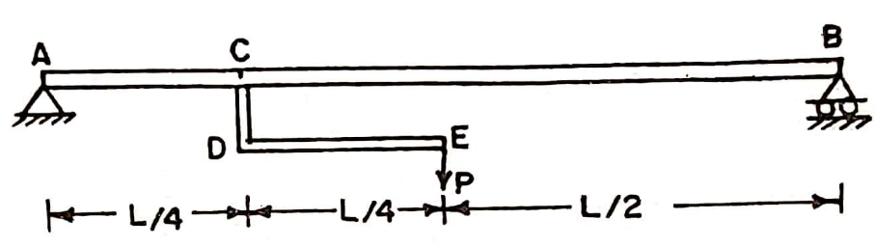Which of the following is the correct shape of SFD (shear force diagram) for the given beam in the diagram? Consider that the member CDE is rigid and connected to beam AB at point C. | 2
Q26_1 | 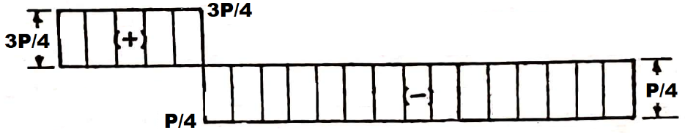
Q26_2 | 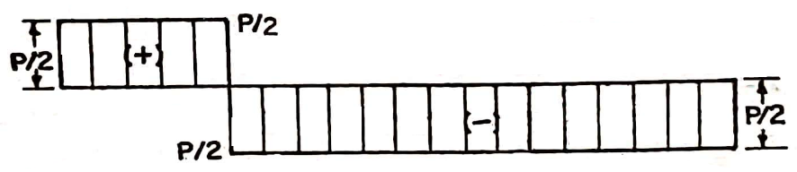
Q26_3 | 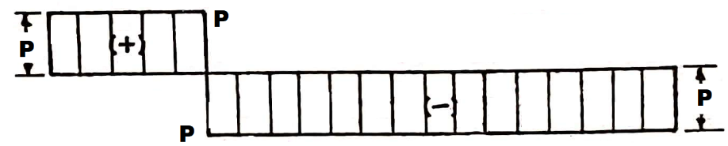
Q26_4 | 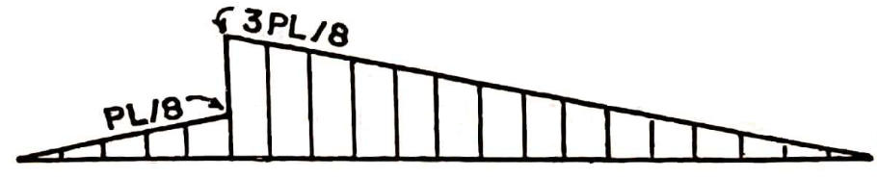
Q27 | Which of the following is incorrect bending equation based on the theory of pure bending? Where, M=Bending moment, I=Moment of inertia exerted on the bending axis, σ= Stress of the fibre at a distance ‘y’ from neutral/centroidal axis, E = Young’s Modulus of beam material, R = Curvature radius of this bent beam and Z=Section modulus of the section | 2
Q27_1 | M = $\frac{EI}{R}$
Q27_2 | M = ZI
Q27_3 | $\frac{σ}{y}$ =$\frac{E}{R}$
Q27_4 | σ =$\frac{EI}{ZR}$
Q28 | Calculate the crippling load for a column using Euler’s theory for long columns, whose effective length is 3 m. Take modulus of elasticity as ‘E’ kN/m² and moment of inertia as ‘I’ m⁴. Consider that both ends of column are fixed. | 3
Q28_1 | 0.30 π²EI kN
Q28_2 | 0.27 π²EI kN
Q28_3 | 0.11 π²EI kN
Q28_4 | 0.42 π²EI kN
Q29 | Moment of total area of a plane lamina about its centroidal axis is equal to _____ | 2
Q29_1 | area of plane lamina
Q29_2 | zero
Q29_3 | 2 times the area of plane lamina
Q29_4 | area of plane lamina divided by its perimeter
Q30 | Calculate the value of $\overline{y}$ (distance from line ‘Ox’ to centroid) for the T section shown in figure.  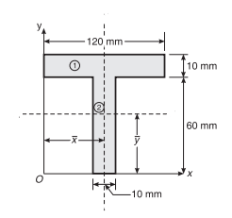 | 2
Q30_1 | 36.72 mm
Q30_2 | 53.33 mm
Q30_3 | 45.22 mm
Q30_4 | 28.76 mm
Q31 | Which of the following test on workability measures the subsidence of concrete in vertical direction to express the degree of workability of concrete? | 1
Q31_1 | Slump test
Q31_2 | Compacting factor test
Q31_3 | Vee Bee Consistometer test
Q31_4 | Flow test
Q32 | If an aggregate fraction passing through IS sieve size 50 mm and retained on 40 mm is said to be flaky, the least dimension of tested sample of aggregate shall be less than _____ | 1
Q32_1 | 27 mm
Q32_2 | 32 mm
Q32_3 | 40 mm
Q32_4 | 53 mm
Q33 | Which of the following is not a desirable property of structural concrete, which is expected to provide good compressive strength? | 2
Q33_1 | Greater compacted density
Q33_2 | Greater permeability
Q33_3 | Reduced porosity
Q33_4 | Reduced segregation and bleeding
Q34 | According to IS 10262:2019, the approximate amount of entrapped air to be expected  in normal (non-air-entrained) concrete is _____percent of volume of concrete, if the nominal maximum size of aggregate used in concrete is 40 mm. | 2
Q34_1 | 0.50
Q34_2 | 0.80
Q34_3 | 1.50
Q34_4 | 2.3
Q35 | According to IS 12269: 2013, what is the minimum fineness value of ordinary Portland cement (grade 53)? | 2
Q35_1 | 5000 m²/kg
Q35_2 | 225 m²/kg
Q35_3 | 3.15 m²/kg
Q35_4 | 100 m²/kg
Q36 | Which of the following property of cement is determined using Blaine’s air permeability test apparatus? | 2
Q36_1 | Consistency of cement paste
Q36_2 | Fineness of cement
Q36_3 | Compressive strength of cement
Q36_4 | Soundness cement
Q37 | Which of the following type of vibrators is suitable for compacting screed concrete layer laid on existing floors with thickness less than 20cm? | 2
Q37_1 | Internal vibrator
Q37_2 | Surface vibrators
Q37_3 | Form vibrators
Q37_4 | Vibrating tables
Q38 | Identify the incorrect statement with respect to concrete making | 3
Q38_1 | Weigh batching is more precise compared to volume batching in making concrete
Q38_2 | Hand compaction in RCC beams and columns is more efficient than compaction by needle vibrators
Q38_3 | Bleeding in concrete leads to laitance formation on concrete surface
Q38_4 | Separation of coarse aggregates from cement mortar in concrete is termed as segregation of concrete
Q39 | Consider below statements with respect to hot and cold weather concreting and identify correct answer.  Statement A : Ice cubes are added in water storages in case of cold weather concreting  Statement B : The rate of hydration of cement concrete in cold weather is faster than that in hot weather. | 4
Q39_1 | Statement A is correct and B is incorrect
Q39_2 | Statement B is correct and A is incorrect
Q39_3 | Both statements are correct
Q39_4 | Both statements are incorrect
Q40 | Which of the following type of cement consist greater quantity of Tricalcium silicate to perform its intended application? | 4
Q40_1 | high alumina cement
Q40_2 | blast furnace slag cement
Q40_3 | Portland pozzolana cement
Q40_4 | rapid hardening cement
Q41 | Side face reinforcement , in case of a RCC deep beams shall not be less than_______ | 1
Q41_1 | 0.2% of the web area
Q41_2 | 0.8% of the web area
Q41_3 | 0.04% of the web area
Q41_4 | 1.0% of the web area
Q42 | Consider below statements with respect to spacing/location of steel reinforcement and identify correct answer  - Spacing of stirrups in a RCC rectangular beam is increased at the mid third portion along the length of beam.  - Flexural reinforcement in a cantilever beam subjected to a uniformly distributed load (neglect the self-weight) directed vertically upwards shall be above the neutral axis of the cross section of beam. | 4
Q42_1 | Statement A is correct B is incorrect
Q42_2 | Statement B is correct A is incorrect
Q42_3 | Both statements are correct
Q42_4 | Both statements are incorrect
Q43 | As per IS 456-2000, The minimum area of longitudinal reinforcement in a RCC column of size 230mmx450 mm, shall not be less than________ | 3
Q43_1 | 464 mm²
Q43_2 | 520 mm²
Q43_3 | 828 mm²
Q43_4 | 1150 mm²
Q44 | As per IS 875 part-2, Imposed loads on class rooms and lecture room floors (not used for assembly purpose) shall not be less than________. Consider type of occupancy as Educational building. | 2
Q44_1 | 1.2 kN/m²
Q44_2 | 3 kN/m²
Q44_3 | 4 kN/m²
Q44_4 | 6 kN/m²
Q45 | Consider below statements with respect to balanced failure is RCC structures and identify correct answer.  Statement A: Balanced failure is expected occur when the compressive strain in the extreme fibre of the concrete reaches the ultimate strain and the tensile strain at the level of centroid of the steel reaches the yield strain.  Statement B: Balanced failure is expected to occur by the simultaneous initiation of crushing of concrete and yielding of steel. | 3
Q45_1 | Statement A is correct and B is incorrect
Q45_2 | Statement B is correct and A is incorrect
Q45_3 | Both statements are correct
Q45_4 | Both statements are incorrect
Q46 | As per IS 875 part-2, Imposed loads on corridors, passages, lobbies and staircases including fire escapes shall not be less than________. Consider that the type of occupancy as Institutional building. | 3
Q46_1 | 2 kN/m²
Q46_2 | 3 kN/m²
Q46_3 | 4 kN/m²
Q46_4 | 10 kN/m²
Q47 | Thickness of the base slab of a RCC cantilever retaining wall should not be less than________ | 2
Q47_1 | 150 mm
Q47_2 | 300 mm
Q47_3 | 330 mm
Q47_4 | 500 mm
Q48 | Consider below statements with respect to Working stress and Limit state design methods and identify correct option.  Statement A: In Working stress method, linear stress strain curve of concrete and steel is considered for design.  Statement B: Limit state is a state of impending failure, beyond which a structure ceases to perform its intended function satisfactorily, in terms of either safety or serviceability. | 4
Q48_1 | Statement A is true and statement B is false
Q48_2 | Statement A is false and statement B is true
Q48_3 | Both statement are false
Q48_4 | Both statement are true
Q49 | Two columns C_{a} and C_{b} spaced 3 m center to center are subjected to axial loads of 600 kN and 800 kN respectively. If good soil for foundation with safe bearing capacity as 200 kN/m², is available at 2 m depth below the ground level, identify the type of foundation which is suitable and economical. Assume width of footing restricted to 2m. | 1
Q49_1 | Isolated footing
Q49_2 | Pile foundation
Q49_3 | Grillage foundation
Q49_4 | Mat foundation
Q50 | Which of the following IS code provides the “general requirements for the design of concrete structures for retaining aqueous liquids”? | 1
Q50_1 | IS 3370(part 1):2021
Q50_2 | IS 800:2007
Q50_3 | IS 516:2012
Q50_4 | IS 10262:2019
Q51 | If actual length of a prismatic compression member is ‘L’, its effective length is equal to_______if one of its one end is restrained against both translation and rotation, and other end is restrained against translation and free to rotate. | 2
Q51_1 | 0.65 L
Q51_2 | 0.8 L
Q51_3 | 1.2 L
Q51_4 | 2.0 L
Q52 | As per IS 875 part-2, in the analysis of an industrial buildings the imposed loads on flat, sloping or curved roof with slopes up to and including 10 degrees shall be ________. Consider that access is provided to roof. | 1
Q52_1 | 1.5 kN/m²
Q52_2 | 0.75 kN/m²
Q52_3 | 3.0 kN/m²
Q52_4 | 5.0 kN/m²
Q53 | Which of the following buckling class is applicable about z-z axis for a rolled steel I-section used as a axially loaded compression member shown in figure, if (h/b_{f}) > 1.2 and t_{f} </= 40 mm?  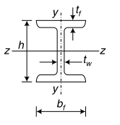 | 4
Q53_1 | Class – d
Q53_2 | Class – b
Q53_3 | Class – c
Q53_4 | Class - a
Q54 | Identify the type of built up column shown in figure.  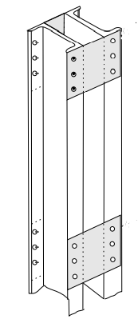 | 1
Q54_1 | Channels back to back connected by battens
Q54_2 | Channels back to back connected by single lacing
Q54_3 | Channels back to back connected by double flat lacing
Q54_4 | Channels back to back connected by double flat lacing with batten
Q55 | Moment rotation behaviour of the four classes of cross sections which are necessary for limit state design of steel beams is shown in figure. Class 2 section is also called as_____  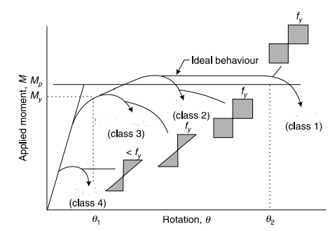 | 3
Q55_1 | Plastic section
Q55_2 | Semi compact section
Q55_3 | Compact section
Q55_4 | Slender section
Q56 | Consider below statements with respect to steel beams and identify correct answer.  Statement A: Web crippling in steel beam occurs due to failure of web under concentrated load  Statement B: Steel beams classified as compact sections attain plastic moment capacity due plastic redistribution of stress | 3
Q56_1 | Statement A is correct and B is incorrect
Q56_2 | Statement B is correct and A is incorrect
Q56_3 | Both statements are correct
Q56_4 | Both statements are incorrect
Q57 | Consider below statements with respect to design of plate girder and identify correct answer.  Statement A: Vertical stiffeners in a bolted plate girder are placed with a maximum spacing of 300 times thickness of web  Statement B: Bearing stiffeners are provided in a plate girder to prevent buckling of web | 2
Q57_1 | Statement A is correct and B is incorrect
Q57_2 | Statement B is correct and A is incorrect
Q57_3 | Both statements are correct
Q57_4 | Both statements are incorrect
Q58 | Identify the type of truss shown in figure  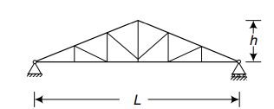 | 1
Q58_1 | Pratt truss
Q58_2 | King post truss
Q58_3 | Fan truss
Q58_4 | Warren truss
Q59 | Which of the following expression is correct to calculate the economical spacing of roof truss? Where, t, p and r are the cost of truss, purlin and roof coverings respectively. | 1
Q59_1 | t=2p+r
Q59_2 | t=p+r
Q59_3 | t=2(p+r)
Q59_4 | t=p+2r
Q60 | Consider below statements with respect to stiffeners used in plate girders and identify correct option.  Statement A: . The main function of the longitudinal stiffeners is to increase the buckling resistance of the web.  Statement B: Load Carrying stiffeners are provided at locations where the compressive forces that are applied through the flange by an external load or reactions exceed the buckling resistance of the web alone. | 4
Q60_1 | Statement A is true and statement B is false
Q60_2 | Statement A is false and statement B is true
Q60_3 | Both statement are false
Q60_4 | Both statement are true

